Year 12 Examination, 2017

Question/Answer Booklet

MATHEMATICS SPECIALIST

Section Two: Calculator-assumed

Student Name/Number: ______________________________________________

Teacher Name: ______________________________________________

Time allowed for this section
Reading time before commencing work: ten minutes
Working time for this section: one hundred minutes

Materials required/recommended for this section
To be provided by the supervisor: This Question/Answer Booklet
Formula Sheet (retained from Section One)

To be provided by the candidate:
Standard items: pens (blue/black preferred), pencils (including coloured), sharpener, correction fluid/tape, eraser, ruler, highlighters
Special items: drawing instruments, templates, notes on two unfolded sheets of A4 paper, and up to three calculators approved for use in the WACE examinations

Important note to candidates
No other items may be taken into the examination room. It is your responsibility to ensure that you do not have any unauthorised notes or other items of a non-personal nature in the examination room. If you have any unauthorised material with you, hand it to the supervisor before reading any further.

Structure of this paper

Section | Number of questions available | Number of questions to be answered | Working time (minutes) | Marks available | Percentage of exam
Section One: Calculator-free | 7 | 7 | 50 | 54 | 35
Section Two: Calculator-assumed | 11 | 11 | 100 | 100 | 65
 |  |  |  |  | 100

Instructions to candidates

- The rules for the conduct of School exams are detailed in the _______________________________________School/College assessment policy. Sitting this examination implies that you agree to abide by these rules.

- Write your answers in this Question/Answer Booklet.

3. You must be careful to confine your responses to the specific questions asked and to follow any instructions that are specific to a particular question.

- Spare pages are included at the end of this booklet. They can be used for planning your responses and/or as additional space if required to continue an answer.
  - Planning: If you use the spare pages for planning, indicate this clearly at the top of the page.
  - Continuing an answer: If you need to use the space to continue an answer, indicate in the original answer space where the answer is continued, i.e. give the page number. Fill in the number of the question that you are continuing to answer at the top of the page.

- Show all working clearly. Your working should be in sufficient detail to allow your answers to be checked readily and for marks to be awarded for reasoning. Incorrect answers given without supporting reasoning cannot be allocated any marks. For any question or part question worth more than two marks, valid working or justification is required to receive full marks. If you repeat any question, ensure that you cancel the answer you do not wish to have marked.

- It is recommended that you do not use pencil, except in diagrams.

- The Formula Sheet is not to be handed in with your Question/Answer Booklet.

Section Two: Calculator-assumed 65% (100 Marks)

This section has 11 questions. Answer all questions. Write your answers in the spaces provided.

Spare pages are included at the end of this booklet. They can be used for planning your responses and/or as additional space if required to continue an answer.
- Planning: If you use the spare pages for planning, indicate this clearly at the top of the page.
- Continuing an answer: If you need to use the space to continue an answer, indicate in the original answer space where the answer is continued, i.e. give the page number. Fill in the number of the question that you are continuing to answer at the top of the page.

Suggested working time: 100 minutes.

Question 8 (6 marks)

Suppose that the complex number
.
- Derive the polar forms of and . (3 marks)

- Use De Moivre’s theorem to evaluate in Cartesian form. (3 marks)

Question 9 (9 marks)

The weight of individual coffee beans in a certain blend is normally distributed with a mean of grams and a standard deviation of grams.

- Estimate and if it is known that 10% of all the beans weigh more than 0.14 gm and 5% of all beans weigh less than 0.11 gm. (3 marks)

- Calculate the probability that the total weight of 10 randomly chosen beans will be less than 1.2 gm. (3 marks)

- What is the probability that the average weight of beans in a random sample of 100 beans will differ from 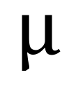 by less than 1 mg? (3 marks)

Question 10 (7 marks)

- Determine the constants and such that (4 marks)

- Hence determine the constant such that (3 marks)

Question 11 (8 marks)

The paths of two planes A and B that are flying in an aeronautics display are given by

and

respectively where . Distances are measured in km and time in minutes.

In the co-ordinate system the vector points vertically upwards from the ground.

- State the position vectors of the two planes when . (1 mark)

- Determine the velocity vectors for each plane. (1 mark)

- Comment on the characteristics of the flight paths of the planes. Make reference to the respective speeds and the vertical direction of their travel. (3 marks)

- Draw a graph to show the distance between the two planes over the time interval to .

Determine the minimum distance between the two planes and state when this closest approach occurs. (3 marks)

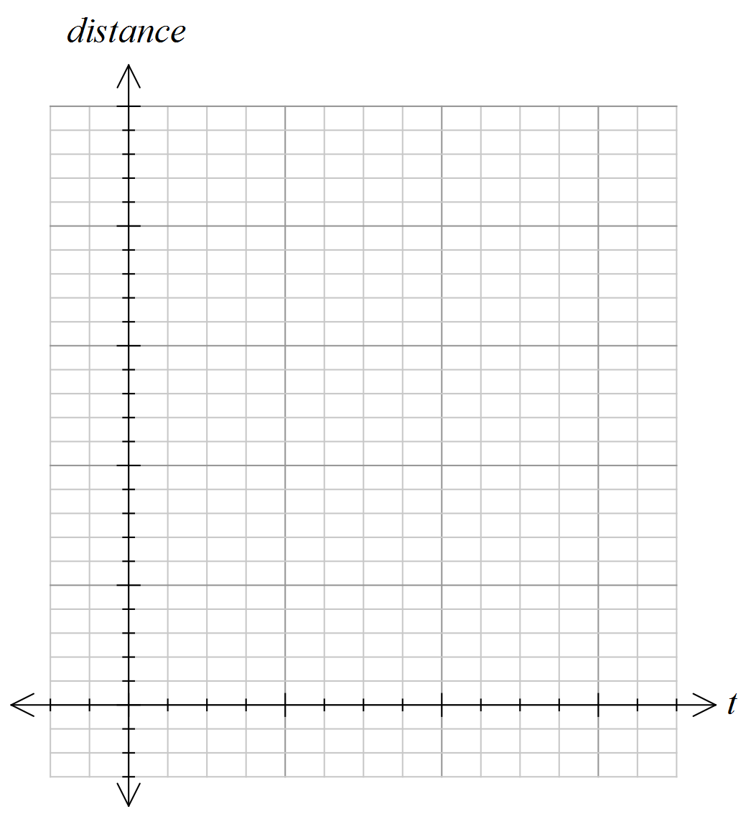

Question 12 (9 marks)

The spread of an infectious disease in a closed community is modelled by the differential equation

where denotes the proportion of the population that is infected on day .

- Explain why the disease is spreading fastest when half the population is infected.
(1 mark)

- Use the differential equation and the identity
to prove that
where 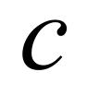 is a constant. (2 marks)

- It is known that initially, when , the infection is in 1% of population.
Deduce that . (2 marks)

- Hence, or otherwise, show that
. (2 marks)

- How long does it take for 95% of the population to become infected? (2 marks)

Question 13 (11 marks)

- (i) Determine the inverse of the function. (3 marks)

(ii) What is the domain and the range of the inverse? (1 mark)

- If and show that .
What is the domain of this composite function? (2 marks)

- By considering the ranges and separately, or otherwise, solve the equation
(5 marks)

Question 14 (8 marks)

Consider the rectangular prism drawn below.

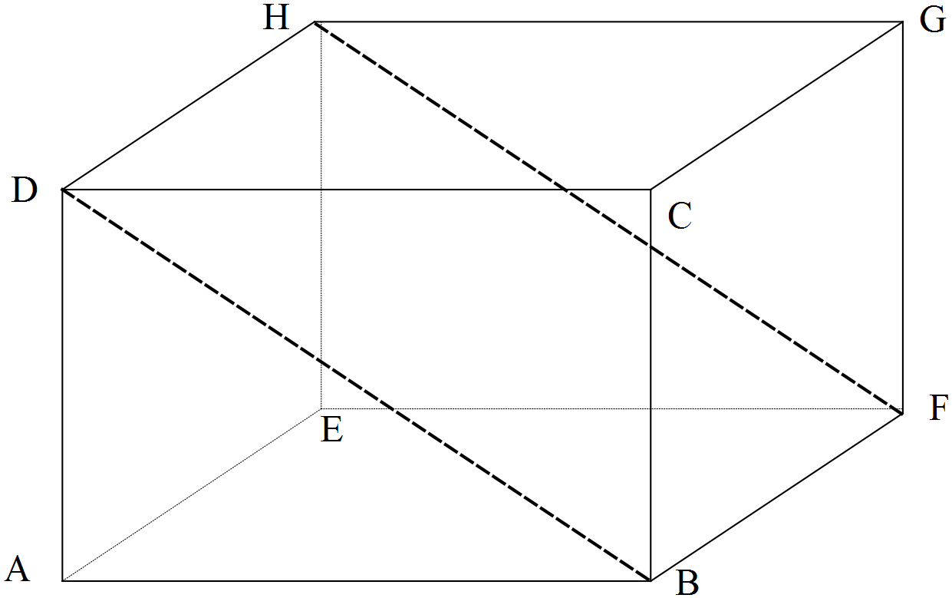

Let the three vectors be denoted respectively.

- Use vector methods to show that . (3 marks)

- Show that . (4 marks)

- Express the result in part (b) in terms of the properties of the quadrilateral DBFH.
(1 mark)

Question 15 (7 marks)

A tyre manufacturer claims that its latest brand can, on average, be safely used for at least 40000 km. It is proposed to test this claim by measuring the safe travelling distance of a random sample of such tyres.

Based on previous tests it can be assumed that the safe travelling distances of this type of tyre are approximately normally distributed with a standard deviation of 3500 km.

- How large should the sample be if we want to be 95% confident that the sample mean differs from the population mean by less than 1000 km? (2 marks)

- Construct a 95% confidence interval for the average safe travelling distance of all of the latest brand of tyres, given that in a random sample of 50 such tyres the average safe travelling distance is 39 103 km. (3 marks)

- Comment on the strength of the evidence provided by this random sample for rejecting the manufacturer’s claim about the average safe travelling distances of this type of tyre.
(2 marks)

Question 16 (7 marks)

Consider the polynomial

.

- Use your calculator and a graph to determine the two real solutions of the equation 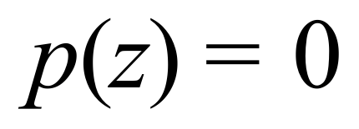 and verify your answers by substitution. (2 marks)

- Find all four complex solutions of. (5 marks)

Question 17 (13 marks)

The displacement cm of a damped spring at time () seconds is given by

where is a constant.

- Show that . (3 marks)

- Determine the value of if at time the velocity is 14 cm/sec. (2 marks)

- When is the spring first stationary? (2 marks)

- Show that the times when the spring is stationary form an arithmetic sequence and state the common difference between consecutive terms. (2 marks)

- Show that the local maximum values of the displacement form a geometric sequence.
(4 marks)

Question 18 (15 marks)

- Calculate the area A bounded by the -axis and the parabola defined by.
(4 marks)

- The area A can be rotated about the-axis to form a solid of volume .
The area A can alternatively be rotated about the-axis to form a solid of volume .

Prove that . (11 marks)

Additional working space
Question number: __________________

Additional working space
Question number: __________________

Acknowledgements

© MAWA, 2017
This examination is Copyright but may be freely used within the school that purchases this licence.
- The items that are contained in this examination are to be used solely in the school for which they are purchased.
- They are not to be shared in any manner with a school which has not purchased their own licence.
- The items and the solutions/marking keys are to be kept confidentially and not copied or made available to anyone who is not a teacher at the school. Teachers may give feedback to students in the form of showing them how the work is marked but students are not to retain a copy of the paper or the marking guide until the agreed release date stipulated in the purchasing agreement/licence.
Published by The Mathematical Association of WA
12 Cobbler Place, MIRRABOOKA 6061

